Name: Muhamad Asyraf Bin Yang Budiman
Matrics ID: CA24045
Lab 3.3
Part A: Measure the Box Model
1. Calculate the border-box width and height, excluding margins.
Border-box width = 250 + 20 + 10 = 280px
Border-box height = 100 + 20 + 10 = 130px
2. Calculate the total dimensions including margins.
Total width = 280 + 20 = 300px
Total height = 130 + 20 = 150px
3. Change padding to 20px and recalculate both widths.
Border-box width = 250 + 40 + 10 = 300px
Total width including margins = 300 + 20 = 320px
4. Comparison with Developer Tools
The CSS Box Model in Developer Tools confirms the calculated dimensions. Padding and borders increase the visible size of the element because the default box-sizing is content-box.
Screenshot:
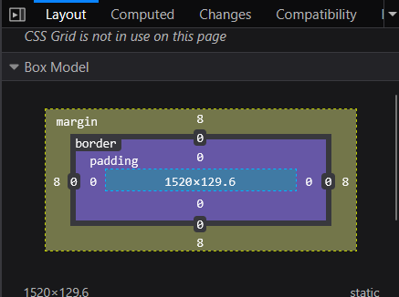

Part B: Build the Club Page and Spacing
Question 1: Expand padding: 40px 20px 20px into its four sides.
- Top: 40px
- Right: 20px
- Bottom: 20px
- Left: 20px
Question 2: Explain why .marked p does not style paragraphs outside .marked.
The .marked p selector is a descendant selector. It only applies to paragraph elements located inside an element with the class marked. Paragraphs outside this element are not affected.
Question 3: How does max-width change the container on a wide screen?
The max-width: 900px property prevents the container from becoming wider than 900 pixels, even on a large screen. This improves readability and keeps the content organized.
Screenshot:
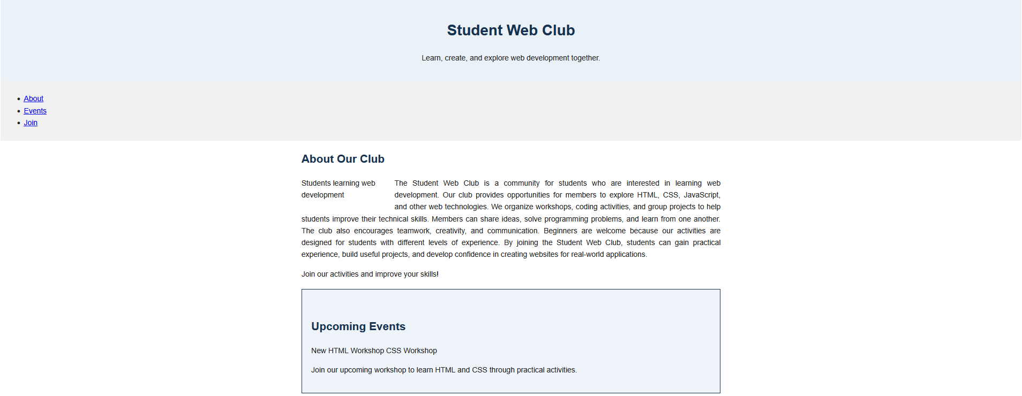


Part C: Display and Positioning
Question 1: Which display value puts each span on a separate line?
The display: block property places each span element on a separate line because block-level elements start on a new line.
Question 2: Why does top: 20px have no effect on a static element?
The top property has no effect because elements with position: static follow the normal document flow and do not respond to positioning offsets.
Question 3: Which element is the positioned ancestor for .badge?
The .event-card element is the positioned ancestor because it uses position: relative. The .badge element uses position: absolute and is positioned relative to the event card.
Question 4: How do relative and absolute positioning differ in their effect on normal document flow?
Relative positioning moves an element visually while keeping its original space in the document flow. Absolute positioning removes the element from normal document flow and positions it relative to its nearest positioned ancestor.
Question 5: How does the sticky menu behave differently from the fixed Top link?
The sticky menu follows the normal document flow until it reaches the top of the viewport, where it stays during scrolling. The fixed Top link remains in the same position relative to the viewport regardless of scrolling.

Screenshots:
